Name: Shivani Suresh

Register Number:2021503050

Semester:5

Batch:2

Course: CS6111- Computer Networks

Lab - Experiment 7 – Implementation of HTTP Server

CODE:

import java.net.*;

import java.io.*;

import java.util.Scanner;

class http_server {

public static void main(String[] args) throws Exception {

System.out.println("Enter port : ");

Scanner dop=new Scanner(System.in);

int port=dop.nextInt();

ServerSocket serverSocket = new ServerSocket(port);

System.err.println("Local Host Server running at : " + port);

while (true) {

Socket clientSocket = serverSocket.accept();

System.err.println("Server connected!");

BufferedReader in = new BufferedReader(new

InputStreamReader(clientSocket.getInputStream()));

BufferedWriter out = new BufferedWriter(new

OutputStreamWriter(clientSocket.getOutputStream()));

String s;

while ((s = in.readLine()) != null) {

System.out.println(s);

if (s.isEmpty()) {

break;

}

}

out.write("HTTP/1.0 200 OK\r\n");

out.write("Server: Apache/0.8.4\r\n");

out.write("Content-Type: text/html\r\n");

out.write("Content-Length: 59\r\n");

out.write("\r\n");

out.write("<TITLE>HTTP Implementation</TITLE>");

out.write("<P>Hello, Shivani here !!</P>");

out.write("<P>"+s+"</P>");

System.err.println("Server Connection Closed\n");

out.close();

in.close();

clientSocket.close();

}

}

}

OUTPUT:

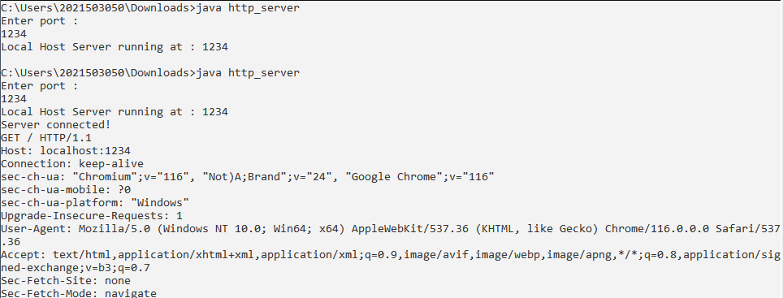

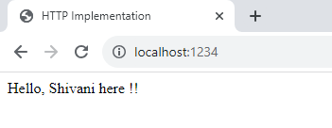

CODE: